BANK ACCOUNT MANAGEMENT
SYSTEM
DBMS CORNERSTONE PROJECT
TEAM MEMBERS
T.Vijay Manikanta (951)
T.Venkata Ramu (957)
U.Pavan Kumar (LE103)
V.Anil Kumar (LE154)

1. PROBLEM STATEMENT
- Banking organizations need to maintain customer, branch, employee, account, loan and transaction information in an organized manner.
- Manual records or separate files can cause duplicate customer information, incorrect account details and data-entry errors.
- Finding account balances, loan information, transaction details and customer records can be time-consuming when information is not centralized.
- A centralized relational database can make banking operations more accurate, organized and efficient.
- The system should maintain relationships between customers, accounts, employees, branches, loans and transactions while preserving data consistency.

2. OBJECTIVES
- Maintain accurate customer and employee records.
- Manage branch and bank account information.
- Maintain savings and checking account details.
- Record account balances, opening dates and account status.
- Manage loan details, borrowers and loan transactions.
- Maintain transaction date, type, amount and description.
- Reduce duplicate records and manual errors.
- Provide quick access to customer, account, loan and transaction information.
- Improve data consistency, security and overall efficiency.

3. END USERS
End User | Responsibilities
Administrator / Bank Management | Manages branches, employees, customers, accounts, loans and transaction information.
Bank Employee | Handles customer records, assists with accounts and manages banking operations assigned to the branch.
Customer | Provides personal details, maintains accounts, performs transactions and may apply for loans.

4. REQUIREMENTS

4.1 Functional Requirements
- Customer registration and customer record management.
- Branch information management.
- Employee registration and branch assignment.
- Account creation and account status management.
- Savings and checking account classification.
- Account balance and opening-date management.
- Loan creation and borrower management.
- Loan transaction recording.
- Transaction search and transaction-history retrieval.
- Account, customer, loan and branch information reporting.

4.2 Non-Functional Requirements
- Security and controlled access to banking information.
- Reliability and data consistency.
- Fast response time and usability.
- Scalability for additional customers, accounts, branches and transactions.
- Backup and recovery of database information.
- Integrity through primary-key and foreign-key constraints.

5. ER DESIGN – ENTITIES & ATTRIBUTES
The following entities and attributes are taken from the supplied Bank Account Management System ER diagram.
Entity | Attributes
BRANCH | Branch_ID (PK), Branch_Name, Address, IFSC_Code
CUSTOMER | Customer_ID (PK), Name, Phone, Email, Address, Date_of_Birth, Gender
EMPLOYEE | Employee_ID (PK), Name, Phone, Email, Role, Employment_Length
ACCOUNT | Account_ID (PK), Account_Type, Balance, Opening_Date, Status
SAVINGS_ACCOUNT | Account_ID (PK, FK), Interest_Rate
CHECKING_ACCOUNT | Account_ID (PK, FK), Overdraft_Amount
LOAN | Loan_ID (PK), Loan_Type, Amount, Interest_Rate, Status, Loan_Date
TRANSACTION | Transaction_ID (PK), Transaction_Type, Transaction_Date, Amount, Description
Primary Key (PK) identifies each entity record uniquely. Foreign Keys (FK) are used in the relational implementation to preserve the relationships shown in the ER model.

6. ER DIAGRAM
Figure 1: Bank Account Management System – ER Diagram
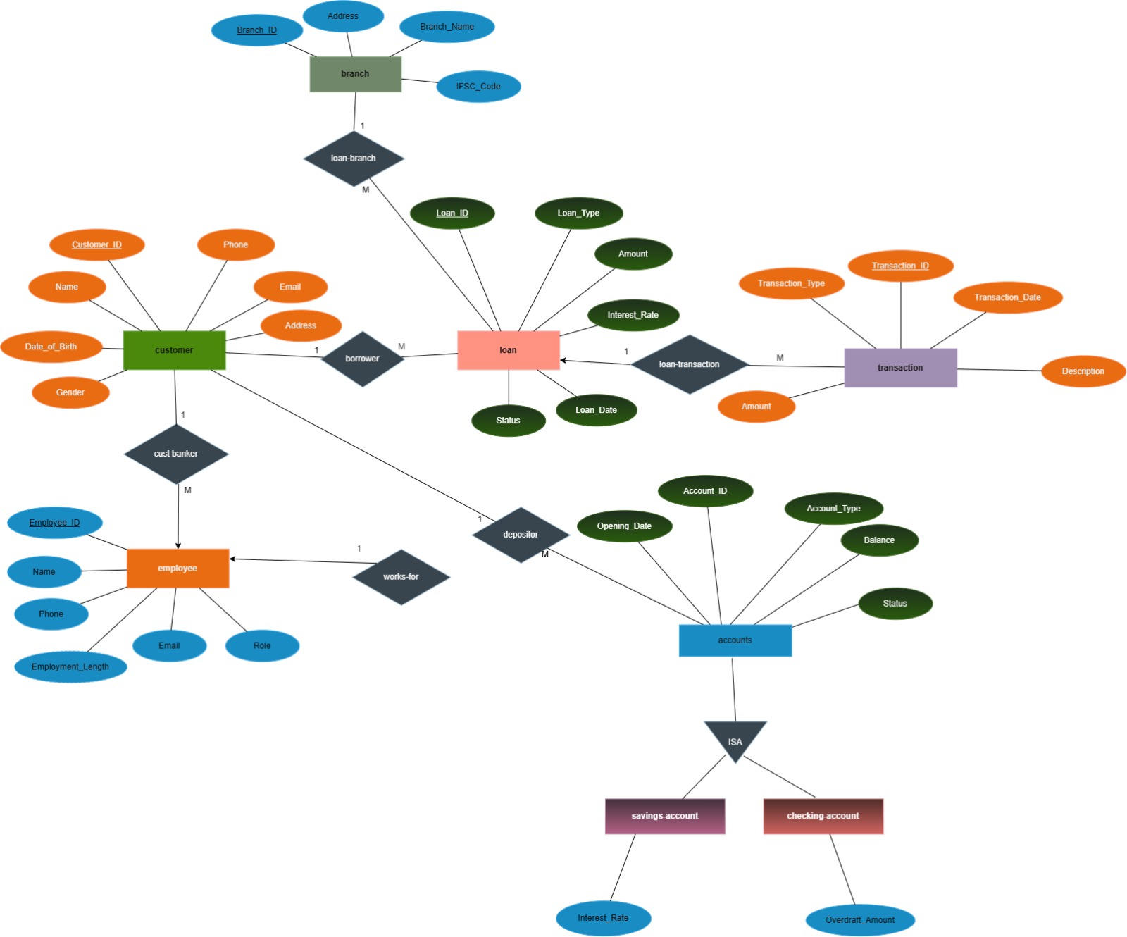
Figure 1: ER Diagram – Bank Account Management System

7. RELATIONAL TABLES
Table | Attributes
BRANCH | Branch_ID (PK), Branch_Name, Address, IFSC_Code
CUSTOMER | Customer_ID (PK), Name, Phone, Email, Address, Date_of_Birth, Gender
EMPLOYEE | Employee_ID (PK), Name, Phone, Email, Role, Employment_Length, Branch_ID (FK)
ACCOUNT | Account_ID (PK), Account_Type, Balance, Opening_Date, Status, Customer_ID (FK)
SAVINGS_ACCOUNT | Account_ID (PK, FK), Interest_Rate
CHECKING_ACCOUNT | Account_ID (PK, FK), Overdraft_Amount
LOAN | Loan_ID (PK), Loan_Type, Amount, Interest_Rate, Status, Loan_Date, Branch_ID (FK), Customer_ID (FK)
TRANSACTION | Transaction_ID (PK), Transaction_Type, Transaction_Date, Amount, Description, Loan_ID (FK)

8. TABLE DESIGN
Table | Attribute | Data Type | Constraint | Description
BRANCH | Branch_ID | INT | PK | Unique branch identifier
BRANCH | Branch_Name | VARCHAR | NOT NULL | Branch name
BRANCH | Address | VARCHAR | NOT NULL | Branch address
BRANCH | IFSC_Code | VARCHAR | UNIQUE | Branch IFSC code
CUSTOMER | Customer_ID | INT | PK | Unique customer identifier
CUSTOMER | Name | VARCHAR | NOT NULL | Customer name
CUSTOMER | Phone | VARCHAR | — | Customer contact number
CUSTOMER | Email | VARCHAR | — | Customer email address
CUSTOMER | Address | VARCHAR | — | Customer address
CUSTOMER | Date_of_Birth | DATE | — | Customer date of birth
CUSTOMER | Gender | VARCHAR | — | Customer gender
EMPLOYEE | Employee_ID | INT | PK | Unique employee identifier
EMPLOYEE | Name | VARCHAR | NOT NULL | Employee name
EMPLOYEE | Phone | VARCHAR | — | Employee contact number
EMPLOYEE | Email | VARCHAR | — | Employee email address
EMPLOYEE | Role | VARCHAR | — | Employee role
EMPLOYEE | Employment_Length | INT | CHECK | Employment length
EMPLOYEE | Branch_ID | INT | FK | References BRANCH
ACCOUNT | Account_ID | INT | PK | Unique account identifier
ACCOUNT | Account_Type | VARCHAR | CHECK | Account classification
ACCOUNT | Balance | DECIMAL | CHECK | Current account balance
ACCOUNT | Opening_Date | DATE | NOT NULL | Account opening date
ACCOUNT | Status | VARCHAR | CHECK | Account status
ACCOUNT | Customer_ID | INT | FK | References CUSTOMER
SAVINGS_ACCOUNT | Account_ID | INT | PK, FK | References ACCOUNT
SAVINGS_ACCOUNT | Interest_Rate | DECIMAL | CHECK | Savings account interest rate
CHECKING_ACCOUNT | Account_ID | INT | PK, FK | References ACCOUNT
CHECKING_ACCOUNT | Overdraft_Amount | DECIMAL | CHECK | Allowed overdraft amount
LOAN | Loan_ID | INT | PK | Unique loan identifier
LOAN | Loan_Type | VARCHAR | NOT NULL | Type of loan
LOAN | Amount | DECIMAL | CHECK | Loan amount
LOAN | Interest_Rate | DECIMAL | CHECK | Loan interest rate
LOAN | Status | VARCHAR | CHECK | Loan status
LOAN | Loan_Date | DATE | NOT NULL | Loan date
LOAN | Branch_ID | INT | FK | References BRANCH
LOAN | Customer_ID | INT | FK | References CUSTOMER
TRANSACTION | Transaction_ID | INT | PK | Unique transaction identifier
TRANSACTION | Transaction_Type | VARCHAR | NOT NULL | Transaction type
TRANSACTION | Transaction_Date | DATE | NOT NULL | Transaction date
TRANSACTION | Amount | DECIMAL | CHECK | Transaction amount
TRANSACTION | Description | VARCHAR | — | Transaction description
TRANSACTION | Loan_ID | INT | FK | References LOAN

9. BASIC SQL QUERIES
Query 1: Display all customers
SELECT *
FROM CUSTOMER;
Query 2: Display active accounts
SELECT Account_ID, Account_Type, Balance, Opening_Date
FROM ACCOUNT
WHERE Status = 'Active';
Query 3: Find accounts with balance greater than ₹50,000
SELECT Account_ID, Account_Type, Balance
FROM ACCOUNT
WHERE Balance > 50000;
Query 4: Display savings accounts
SELECT a.Account_ID, a.Balance, s.Interest_Rate
FROM ACCOUNT a
JOIN SAVINGS_ACCOUNT s
ON a.Account_ID = s.Account_ID;
Query 5: Display checking accounts
SELECT a.Account_ID, a.Balance, c.Overdraft_Amount
FROM ACCOUNT a
JOIN CHECKING_ACCOUNT c
ON a.Account_ID = c.Account_ID;
Query 6: Display loans above ₹1,00,000
SELECT Loan_ID, Loan_Type, Amount, Interest_Rate, Status
FROM LOAN
WHERE Amount > 100000;
Query 7: Display transactions in descending amount
SELECT Transaction_ID, Transaction_Type, Transaction_Date, Amount
FROM TRANSACTION
ORDER BY Amount DESC;
Query 8: Calculate total transaction amount
SELECT SUM(Amount) AS Total_Transaction_Amount
FROM TRANSACTION;
Query 9: Find customers whose name starts with 'A'
SELECT Customer_ID, Name, Phone, Email
FROM CUSTOMER
WHERE Name LIKE 'A%';
Query 10: Display branches with their IFSC codes
SELECT Branch_ID, Branch_Name, IFSC_Code
FROM BRANCH
ORDER BY Branch_ID;

10. ADVANCED SQL QUERIES
Advanced Query 1 — Customer and their accounts
SELECT
c.Customer_ID,
c.Name AS Customer_Name,
a.Account_ID,
a.Account_Type,
a.Balance,
a.Status
FROM CUSTOMER c
JOIN ACCOUNT a
ON c.Customer_ID = a.Customer_ID
ORDER BY c.Customer_ID;
Advanced Query 2 — Employees and their branches
SELECT
e.Employee_ID,
e.Name AS Employee_Name,
e.Role,
b.Branch_ID,
b.Branch_Name,
b.IFSC_Code
FROM EMPLOYEE e
JOIN BRANCH b
ON e.Branch_ID = b.Branch_ID
ORDER BY b.Branch_ID, e.Employee_ID;
Advanced Query 3 — Customers and their loans
SELECT
c.Customer_ID,
c.Name AS Customer_Name,
l.Loan_ID,
l.Loan_Type,
l.Amount,
l.Interest_Rate,
l.Status
FROM CUSTOMER c
JOIN LOAN l
ON c.Customer_ID = l.Customer_ID
ORDER BY c.Customer_ID;
Advanced Query 4 — Loan, branch and borrower details
SELECT
l.Loan_ID,
c.Name AS Customer_Name,
b.Branch_Name,
l.Loan_Type,
l.Amount,
l.Status
FROM LOAN l
JOIN CUSTOMER c
ON l.Customer_ID = c.Customer_ID
JOIN BRANCH b
ON l.Branch_ID = b.Branch_ID
ORDER BY l.Amount DESC;
Advanced Query 5 — Loan transactions
SELECT
l.Loan_ID,
l.Loan_Type,
t.Transaction_ID,
t.Transaction_Type,
t.Transaction_Date,
t.Amount,
t.Description
FROM LOAN l
JOIN TRANSACTION t
ON l.Loan_ID = t.Loan_ID
ORDER BY l.Loan_ID, t.Transaction_Date;
Advanced Query 6 — Total account balance for each customer
SELECT
c.Customer_ID,
c.Name AS Customer_Name,
SUM(a.Balance) AS Total_Balance
FROM CUSTOMER c
JOIN ACCOUNT a
ON c.Customer_ID = a.Customer_ID
GROUP BY c.Customer_ID, c.Name
ORDER BY Total_Balance DESC;
Advanced Query 7 — Accounts with balance above average
SELECT
Account_ID,
Account_Type,
Balance
FROM ACCOUNT
WHERE Balance >
(
SELECT AVG(Balance)
FROM ACCOUNT
)
ORDER BY Balance DESC;
Advanced Query 8 — Total loan amount by branch
SELECT
b.Branch_ID,
b.Branch_Name,
SUM(l.Amount) AS Total_Loan_Amount
FROM BRANCH b
JOIN LOAN l
ON b.Branch_ID = l.Branch_ID
GROUP BY b.Branch_ID, b.Branch_Name
ORDER BY Total_Loan_Amount DESC;
Advanced Query 9 — Customer, account and branch-related employee information
SELECT
c.Customer_ID,
c.Name AS Customer_Name,
a.Account_ID,
a.Account_Type,
a.Balance,
e.Employee_ID,
e.Name AS Employee_Name,
e.Role
FROM CUSTOMER c
JOIN ACCOUNT a
ON c.Customer_ID = a.Customer_ID
JOIN EMPLOYEE e
ON c.Customer_ID = e.Employee_ID
ORDER BY c.Customer_ID;
Advanced Query 10 — Transactions above average amount
SELECT
Transaction_ID,
Transaction_Type,
Transaction_Date,
Amount,
Description
FROM TRANSACTION
WHERE Amount >
(
SELECT AVG(Amount)
FROM TRANSACTION
)
ORDER BY Amount DESC;
Note: Advanced queries are written directly from the relationships represented in the supplied ER model. Query 9 is included as an example of a multi-table retrieval pattern; in an implemented database, the customer–employee relationship should be represented by an explicit foreign key or junction table if direct joins are required.

11. NORMALIZATION
Normalization is the process of organizing data into proper relations to reduce data redundancy, prevent update anomalies and improve data consistency.

11.1 First Normal Form (1NF)
The Bank Account Management System satisfies 1NF when every attribute contains atomic values, there are no repeating groups or multivalued attributes, and each relation has a primary key that uniquely identifies each record.
Examples of atomic attributes include Customer_Name, Phone, Email, Account_Type, Balance, Loan_Type and Transaction_Type. Savings-account and checking-account-specific attributes are stored in their respective subtype relations.
Representative functional dependencies:
- Customer_ID → Name, Phone, Email, Address, Date_of_Birth, Gender
- Account_ID → Account_Type, Balance, Opening_Date, Status, Customer_ID
- Loan_ID → Loan_Type, Amount, Interest_Rate, Status, Loan_Date, Branch_ID, Customer_ID
- Transaction_ID → Transaction_Type, Transaction_Date, Amount, Description, Loan_ID

11.2 Second Normal Form (2NF)
The relations are already in 1NF. The main relations use single-attribute primary keys, so partial dependency on a part of a composite primary key does not occur. Therefore, the relations satisfy 2NF when every non-key attribute depends on the complete primary key.
Example:
Account_ID → Account_Type, Balance, Opening_Date, Status, Customer_ID
Customer_ID → Name, Phone, Email, Address, Date_of_Birth, Gender

11.2.1 2NF Decomposition
- CUSTOMER(Customer_ID, Name, Phone, Email, Address, Date_of_Birth, Gender)
- ACCOUNT(Account_ID, Account_Type, Balance, Opening_Date, Status, Customer_ID)
- EMPLOYEE(Employee_ID, Name, Phone, Email, Role, Employment_Length, Branch_ID)
- BRANCH(Branch_ID, Branch_Name, Address, IFSC_Code)
- LOAN(Loan_ID, Loan_Type, Amount, Interest_Rate, Status, Loan_Date, Branch_ID, Customer_ID)
- TRANSACTION(Transaction_ID, Transaction_Type, Transaction_Date, Amount, Description, Loan_ID)
- SAVINGS_ACCOUNT(Account_ID, Interest_Rate)
- CHECKING_ACCOUNT(Account_ID, Overdraft_Amount)

11.3 Third Normal Form (3NF)
A relation is in 3NF when it is already in 2NF and has no transitive dependency. Non-key attributes should depend directly on the primary key of their own relation.
Example of a dependency that should not be stored redundantly in ACCOUNT:
Account_ID → Customer_ID → Customer_Name
Customer_Name depends on Customer_ID, not directly on Account_ID. Therefore, customer details remain in CUSTOMER and ACCOUNT stores Customer_ID as a foreign key.

11.3.1 3NF Decomposition
- Step 1: Separate CUSTOMER information from ACCOUNT information.
- Step 2: Keep Customer_ID as a foreign key in ACCOUNT.
- Step 3: Keep branch information in BRANCH and Branch_ID as a foreign key in EMPLOYEE and LOAN.
- Step 4: Keep loan information in LOAN and transaction information in TRANSACTION.
- Step 5: Keep savings-specific and checking-specific attributes in subtype tables.
Relation | Primary Key | Important Foreign Keys
CUSTOMER | Customer_ID | —
BRANCH | Branch_ID | —
EMPLOYEE | Employee_ID | Branch_ID
ACCOUNT | Account_ID | Customer_ID
SAVINGS_ACCOUNT | Account_ID | Account_ID → ACCOUNT
CHECKING_ACCOUNT | Account_ID | Account_ID → ACCOUNT
LOAN | Loan_ID | Customer_ID, Branch_ID
TRANSACTION | Transaction_ID | Loan_ID

12. FINAL 3NF RELATIONS
Relation | Final Attributes
CUSTOMER | Customer_ID (PK), Name, Phone, Email, Address, Date_of_Birth, Gender
BRANCH | Branch_ID (PK), Branch_Name, Address, IFSC_Code
EMPLOYEE | Employee_ID (PK), Name, Phone, Email, Role, Employment_Length, Branch_ID (FK)
ACCOUNT | Account_ID (PK), Account_Type, Balance, Opening_Date, Status, Customer_ID (FK)
SAVINGS_ACCOUNT | Account_ID (PK, FK), Interest_Rate
CHECKING_ACCOUNT | Account_ID (PK, FK), Overdraft_Amount
LOAN | Loan_ID (PK), Loan_Type, Amount, Interest_Rate, Status, Loan_Date, Branch_ID (FK), Customer_ID (FK)
TRANSACTION | Transaction_ID (PK), Transaction_Type, Transaction_Date, Amount, Description, Loan_ID (FK)
PK = Primary Key | FK = Foreign Key

13. RELATIONSHIPS & CARDINALITY
- Branch → Loan = 1:M – one branch can be associated with many loans.
- Customer → Loan = 1:M – one customer can borrow multiple loans.
- Loan → Transaction = 1:M – one loan can have multiple loan-related transactions.
- Customer → Account = 1:M – one customer can maintain multiple accounts.
- Branch → Employee = 1:M – one branch can have many employees.
- Customer → Employee = M:1 from the customer side – multiple customers can be handled by an employee as the customer-banker relationship shown in the ER model.
- Account → Savings Account / Checking Account = 1:1 subtype relationship – an account is specialized as a savings account or checking account according to the ISA structure.

14. RELATION SCHEMA
Relation | Relational Schema
CUSTOMER | CUSTOMER(Customer_ID, Name, Phone, Email, Address, Date_of_Birth, Gender)
BRANCH | BRANCH(Branch_ID, Branch_Name, Address, IFSC_Code)
EMPLOYEE | EMPLOYEE(Employee_ID, Name, Phone, Email, Role, Employment_Length, Branch_ID)
ACCOUNT | ACCOUNT(Account_ID, Account_Type, Balance, Opening_Date, Status, Customer_ID)
SAVINGS_ACCOUNT | SAVINGS_ACCOUNT(Account_ID, Interest_Rate)
CHECKING_ACCOUNT | CHECKING_ACCOUNT(Account_ID, Overdraft_Amount)
LOAN | LOAN(Loan_ID, Loan_Type, Amount, Interest_Rate, Status, Loan_Date, Branch_ID, Customer_ID)
TRANSACTION | TRANSACTION(Transaction_ID, Transaction_Type, Transaction_Date, Amount, Description, Loan_ID)
Foreign keys establish relationships between related tables and help maintain referential integrity.

15. EXPECTED OUTCOME
- Centralized database for customers, branches, employees, accounts, loans and transactions.
- Faster retrieval of customer, account, loan and transaction information.
- Improved management of savings and checking accounts.
- Reduced duplicate data and improved consistency.
- Easy retrieval of account balances and banking history.
- Better control of relationships through primary keys and foreign keys.
- A strong foundation for SQL queries, normalization, reports and future banking application development.

16. CONCLUSION
- The Bank Account Management System provides a structured way to manage core banking information.
- The ER model defines the required entities, attributes, relationships and cardinalities.
- Primary keys and foreign keys organize the database and maintain valid relationships between related records.
- Normalization reduces redundancy and helps maintain consistency across customer, account, branch, employee, loan and transaction data.
- The system can later be extended with additional banking services, stronger authentication, transaction processing, reporting and application interfaces.

17. REFERENCES
- Supplied Bank Account Management System ER Diagram.
- Database Management System course material.
- SQL, relational schema, normalization and database design concepts used in the project.
- Friend's Vehicle Rental Management System documentation supplied as the structural reference for this documentation.

